Fillmore Central School
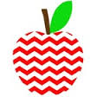
Miss Hatch’s Second Grade
School Supplies for 2018-2019

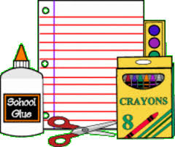

*1 box of tissues
*1 plastic pocket folder
*1 box of Crayola colored pencils
*1 box of Crayola crayons
*1 dozen #2 pencils (Pre-sharpened please )
*1 package of Bic Mechanical Pencils
*1 bottle of hand sanitizer
*1 boxed snack to share with the class

We will be using a snack calendar in 2nd grade. This will start in October
We have everything else your child will need. It will be a great year!!

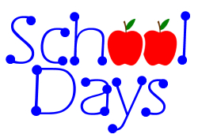
Have a great summer!
Miss Hatch

***Donations of cups, plates, napkins, and plastic silverware are
always appreciated. We use these items for class parties. Thanks!***

